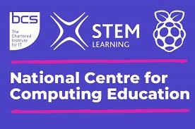

SUBJECT MATTER EXPERTS

The DfE is funding support for schools that wish to improve or update the teaching and learning of computing. The National Centre for Computing Education (NCCE) has been set up to offer this support, which includes:

Bespoke 1:1 support from a Subject Matter Expert (half a day)
Support with planning, resources, and assessment
Access to the NCCE's Teach Computing curriculum (KS1 - 4)
Tailored CPD for all staff
Free online courses
Face-to-face and remote courses with a bursary of £220 for completing a course*

(*the first teacher from each school is eligible for a one-off bursary for a course completed remotely or face to face and taking place within school hours)

To access this offer, please email:

Primary
h.cotton@stem.org.uk
c.elliott@stem.org.uk

Secondary
c.garside@stem.org.uk
p.jones@stem.org.uk

Further information about the NCCE can be found at https://teachcomputing.org/

